Chapter 17, Solution 45.

ω_{n} = 1000n

jω_{n}L = j1000nx2x10^{–3} = j2n

1/(jω_{n}C) = –j/(1000nx40x10^{–6}) = –j25/n

Z = R + jω_{n}L + 1/(jω_{n}C) = 10 + j2n – j25/n

I = V/Z

For n = 1, V₁ = 100, Z = 10 + j2 – j25 = 10 – j23

I₁ = 100/(10 – j23) = 3.987∠73.89°

For n = 2, V₂ = 50, Z = 10 + j4 – j12.5 = 10 – j8.5

I₂ = 50/(10 – j8.5) = 3.81∠40.36°

For n = 3, V₃ = 25, Z = 10 + j6 – j25/3 = 10 – j2.333

I₃ = 25/(10 – j2.333) = 2.435∠13.13°

I_{rms} = 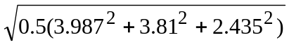 = 4.263 A

p = R(I_{rms})² = 181.7W

